Subject: Global Studies I
Benchmark: Parthenon
Standards: 2A, 2B, 2C, 3A, 5A

TOPIC: Victory and Defeat in the Greek World

MAJOR IDEA: Democracy thrived in Greece, and particularly in the city-state of Athens following the Persian Wars, which began in 490 B.C. and ended in 479 B.C. After the wars, the city-state of Athens rose to a position of hegemony in the Greek world, although continuing conflict with the city-state of Sparta led to the Peloponnesian War, which began in 431 B.C. After the Peloponnesian War, Greece fell into a period of decline, and its influence and power ended.

SUGGESTED AIMS:
- What are the causes of war? What events can bring societies to wage war against one another? Why are wars fought?
- What were the Persian Wars? When were they fought? Why were they fought? Who were the warring parties? Who won? What changes in Greek society and political systems were brought about by the end of the Persian Wars?
- What is an alliance? Why do societies or cultures that may often spar with one another join forces against a common enemy? Why can this be beneficial?
- Why is the Parthenon considered an icon of the golden age of Pericles? Who was Pericles? What role did he play in the Persian Wars? How does the architecture of the Parthenon represent the ideals of Greek society?
- What was the Peloponnesian War? When was it fought? Why was it fought? What was the result?
- What can happen to buildings and monuments during war? Can damage be prevented? How can societies who are at war protect their historic buildings and monuments?
- Can damage to a building be a symbolic act of war?
- Was the Parthenon a casualty of war? Why? When?

VISUAL EXAMPLES:
- Image of the Parthenon
- Image of pediment sculptures (from the Parthenon)
- Map of Greece

SUGGESTED ACTIVITIES:
- Students may imagine that they are interviewing some of the key figures from the Persian and Peloponnesian Wars. They may write a transcript of questions and responses they imagine they would get from Darius, Xerxes, Themistocles, and Leonidas.
- During the Persian Wars, Athens was burned and sacked. Students may develop a rebuilding plan for Athens. What buildings would they rebuild? What new buildings would they construct? Would they incorporate a memorial? How did the Athenians treat the rebuilding of the Parthenon? Would the students do the same? Different?
- Pericles was the driving force behind the construction of the Parthenon. Students may imagine that Pericles is presenting his plan for the Parthenon to the citizenry. Write a speech as if you are Pericles, describing the Parthenon and its importance to the people of Athens.
- Stage a meeting of the Delian League mapping out strategy against the Persians. Representatives of Sparta, Athens, and other Greek city-states may be represented at this meeting.
- After Athens was burned, the Parthenon was rebuilt on the remains of an earlier Parthenon that was destroyed during the Persian Wars. Students may hold a mock public hearing to determine how the Parthenon should be rebuilt. Some students may argue that the Parthenon should be constructed on an entirely new site. Some may argue that it should be rebuilt on top of the ruins. A “commission” may determine the outcome depending on the forcefulness and persuasiveness of the arguments.
- The sculptural elements of the Parthenon were originally polychromatic. Students may propose a color scheme for the sculptural compositions. Draw one of the metopes that depict a battle in the Persian War. Add color and label all the figures shown in the metope.

RESOURCES:
- www.astarte.com.au/History_Resoursces/Ancient_Civilisations/The_Persian_Wars/the_persian_wars.html The Persian Wars video. Filmed on location in Greece.
- http://ancienthistory.about.com/library/bl/bl_time_persianwars.htm Persian Wars timeline
- http://classics.mit.edu/Thucydides/pelopwar.html History of the Peloponnesian War by Thucydides, Ancient Greek historian. Translated.

HOMEWORK:
- Write a newspaper editorial either in support of or against joining the Delian League.
- Generate a list of American buildings that derive their style from the Parthenon. For each building, answer the following questions: 1) What is the name of the building? 2) Where is it? 3) What use does the building have ? (i.e., is it a public/government building, church, school, private residence, etc.) 4) Why do you think the builders chose to build in the Greek style?
- The Parthenon was built to serve a religious purpose. Many American buildings that use the Greek style are government buildings. Students may write an essay describing why they think a building that was religious in its nature came to serve as the model of so many buildings that are used for a secular purpose.
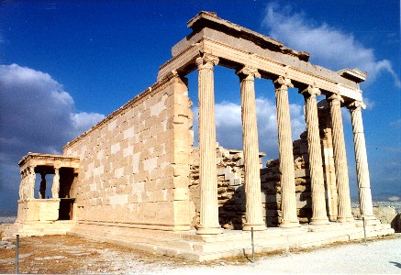
The Parthenon

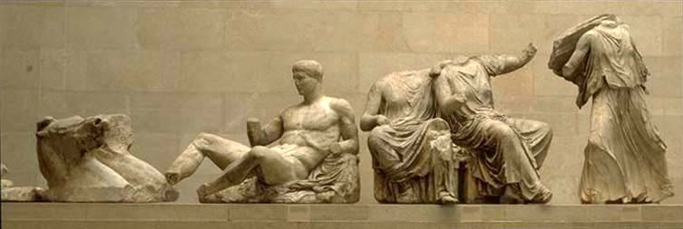
Parthenon pediment sculpture
(other examples in the benchmark binder).

